Feel the Stress Worksheet Answers
Introduction
In engineering we need to know how much stress a material can handle before it fails. Today, let’s explore why it hurts more to press down on your hand with mechanical pencil lead than to push on your hand with a pencil eraser. We can do this by calculating the stress in each, when we push down on the lead and the eraser, with the same amount of force.
Procedure
Follow the instruction steps listed below:
- Make sure that you have a mechanical pencil and verify that it is 0.7mm lead and has an eraser.
- Test the mechanical pencil lead by gently pressing the mechanical pencil lead on the tip of your finger.
- Record what you observe in the observations section.
- Next, test the mechanical pencil eraser by gently pressing it on the tip of your finger with the same amount of force you used with the mechanical pencil lead.
- Record what you observe in the observations section.
- Complete the questions that follow.

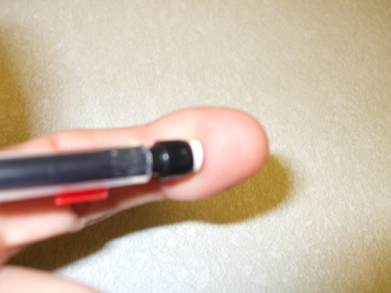
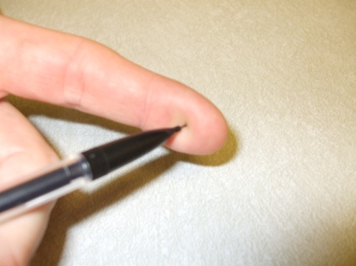
Procedure step 2.

Procedure step 4.

Observations
Rate the amount of stress the pencil lead and the eraser puts on your finger using a scale of 1 to 5
(5 being the most pressure and 1 the least).

Mechanical pencil lead stress scale: 1 2 3 4 5

Mechanical pencil eraser stress scale: 1 2 3 4 5

Measure and record the diameter of the pencil lead and the eraser:

Pencil lead diameter: ______0.7______ (mm)

Pencil eraser diameter: ______6________ (mm)

Investigation Questions
- Did the lead or the eraser place more stress on your finger?

The lead.

- Why did one of these materials place more stress on your finger than the other?

All the force was focused on a smaller point on my finger.

Calculate the radius of the pencil lead and the pencil eraser and record your answers below.

Radius of mechanical pencil lead: _______0.35______ (mm)

Radius of mechanical pencil eraser: _______3________ (mm)

Convert the radius of the pencil lead and the pencil eraser to meters (m), and record your answers below. (Remember that 1m = 1000mm)

Radius of mechanical pencil lead: ________.00035_____ (m)

Radius of mechanical pencil eraser: _______.003________ (m)

The equation for the diameter of a circle is:

$$A=π∙r^{2}$$

is equal to 3.14
r is equal to the radius of either the eraser or the lead
A is equal to cross-sectional area

- Calculate the cross-sectional area of both the mechanical pencil lead and the eraser in m².

Mechanical pencil lead area: ______.000000385______ (m²)

Mechanical pencil eraser area: _______.0000283_______ (m²)

Let’s assume that we pushed each against our fingers with a force of 1 Newton. Calculate the amount of stress each material imposed on your finger using the equation for stress, below:

$$σ_{stress}=\frac{F}{A}$$
F is equal to force
A is equal to cross-sectional area.
is equal to stress

- Calculate the stress the mechanical pencil lead and eraser imposed on your finger in Pascals (N/m²).

Mechanical pencil lead stress: ____2,597,402.6________ (Pa)

Mechanical pencil eraser stress:_____35,335.7_________ (Pa)

- What about the mechanical pencil lead made it hurt more or impose more stress on your finger?

The mechanical pencil lead has a smaller cross-sectional area than the eraser.

- Now that we can see that the smaller the area, the larger the stress. Let’s apply this concept to structural engineering. If I was designing a second story storage room for cases of paint, would I want to stack all of the cases of paint in one corner of the room or spread the cases evenly over the storage room? Why? Use the concept of stress that we just learned to help you explain.

Spread the cases evenly because the larger the area, the less stress is concentrated on any one part of the floor.

- Engineers often have to consider constraints in their designs, such as cost. By spreading the cases of paint across the floor the stress is reduced, so a lighter and cheaper floor might be used. Why might this be a bad idea? List several reasons.

A more expensive, thicker floor is better because if someone does happen to stack the paint cases in the corner of the room, the floor will not fail. Also, paint cases could be stacked, leaving the rest of the room available for other purposes.

- Suppose you were designing a column. The column is subjected to a stress of 70 Mpa. How would you change the area of the column to reduce the stress?

Increase the cross-sectional area.

