Post-Assessment Questions Answer Key
Answer the following questions using complete sentences.
- What is the engineering design process? Why do engineers use it?
The engineering design process is a systematic process—a series of steps—that engineers follow to solve problems based on existing knowledge, their own creativity and the real-world boundary constraints (or parameters) of the situation. Engineers are guided by the steps of the engineering design process as they develop solutions that solve real-world problems without creating additional problems!
- What are the P, QRS and T complexes? Draw a picture to help you explain.
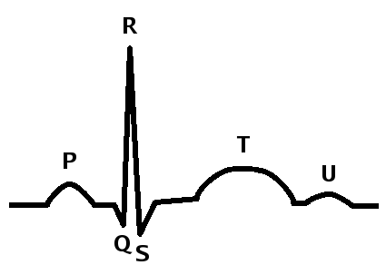
The P, QRS and T complexes are graphical deflections seen on typical electrocardiograms (ECGs), as pictured and identified in this line drawing.

- Give one reason why heart bioelectricity is important for the human body.
Heart bioelectricity—the electrical signals that propagate through the heart—determine when the heart beats, which affects how it pumps blood. Measuring bioelectrical signals in the heart using cardiac ECGs is a good way to determine the health of a person’s heart muscle.

- What are the functions of the action potential? How does action potential propagation happen in the heart?
An action potential is when the electrical potential of a cell rises rapidly and then falls. Action potentials are created by voltage-gated ion channels in cell membranes that let ions (positively or negatively charged particles) pass into and out of the cell at certain times. In the heart, action potentials travel from one cardiac muscle cell to the next, causing muscle cells to contract in sequence, and this is how the heart beats and pumps blood.

- Why is it important for biomedical engineers to understand how the heart works?
Biomedical engineers must understand how the heart works so that they can develop therapies (such as drugs and medical devices) to fix the heart when it is diseased or injured and so that they can develop better imaging technologies for diagnosing heart problems. For example, biomedical engineers use their understanding of how the heart works to develop non-invasive imaging tools, such as magnetic resonance imaging (MRI), to better diagnose cardiac arrhythmias, which is when the electrical signals in the heart are messed up.

