Injury Area Background Information: Skin

During the accident, Bill lost approximately one cubic inch of skin on his left arm, covering four square inches.
Skin provides multiple vital physiological functions, including body temperature regulation, protection from the environment, and water retention.
Skin has three main layers:
The epidermis: The outermost section of the skin gives it its “stretchiness” and is responsible for water retention. Openings enable sweat glands and hair follicles to exit through the skin.
Cell Types | ECM Type | Relative Size
- Mainly keratinocytes—a type of skin cell  - Contributes to the barrier function of the skin  - Cells are packed very densely | - Made of the biomaterial collagen, the main structural protein in human connective tissue | Approximately 1/6 of the total tissue width
The dermis: The middle section of the skin contains connective tissue, nerves, as well as hair and sweat glands. Capillaries are found here, which permit the oxygen and nutrients contained in blood to be exchanged with carbon dioxide and waste found in the tissue.
Cell Types | ECM Type | Relative Size
- Mainly fibroblasts—cells that produce collagen  - Cells are packed very loosely | - Made of collagen  - Very dense concentration of collagen | Approximately 1/2 of the total tissue width
The hypodermis / subcutaneous tissue: The innermost section of the skin is mainly fat tissue. Arteries and veins are found here, which deliver blood to and from the capillaries.
Cell Types | ECM Type | Relative Size
- Mainly adipocytes—fat cells  - Cells are packed very densely | - Made of collagen and elastin, the main protein that gives structures elasticity  - Very loose concentration of collagen and elastin | Approximately 1/3 of the total tissue width

Injury Area Background Information: Bone
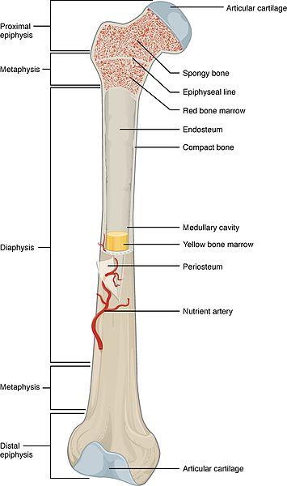

During the accident, an approximately one-inch tall section of Bill’s femur was completely shattered beyond repair; the diameter of his femur is approximately one inch. The femur is the long bone that runs down the upper leg and is crucial for walking.
Our plan is to use a 3D bioprinter to produce a new section of bone for Bill. By introducing it between the two healthier pieces, then putting the leg in a cast for close to a year, we believe that his body will connect the three bone pieces and make it whole again. The femur is a “hard bone,” which takes on a lot of the stress from bearing Bill’s weight.
Hard bone has three main layers:
The periosteum: The outermost layer of bone is a dense, fibrous layer of collagen.
Cell Types | ECM Type | Relative Size
- Almost no cells | - Made out of the biomaterial collagen, the main structural protein in human connective tissue  - Very densely packed collagen | Approximately 1/10 of the total bone width
The cortical / compact bone:
Cell Types | ECM Type | Relative Size
- Almost no cells | - Mainly hydroxyapatite, a crystallized form of calcium combined with collagen  - This is what gives the bone its strength and hardness | Approximately 2/5 of the total bone width
The medullary cavity: The innermost section of bone contains yellow marrow and arteries responsible for nutrient transportation.
Cell Types | ECM Type | Relative Size
- Adipocytes—fat cells  - Osteoclasts—build new bone  - Osteoblasts—break down old bone | - Mainly fibronectin, a protein important for cells sticking together, growth, migration and wound healing  - Collagen | Approximately 1/2 of the total bone width

Injury Area Background Information: Muscle
During the accident, Bill lost three cubic inches of his rectus femoris, one of the large “skeletal muscles” that controls his femur, which is the bone in his upper leg. The rectus femoris is part of the quadricep group and is crucial for walking and running.
By printing a new section of muscle, we can restore Bill’s leg to its previous strength. Studies have shown that nerves “innervate” (connect to and control) replaced muscle tissue after implantation.
Skeletal muscle is made of many tube-shaped skeletal muscle fibers (a single fiber is shown below) all stacked in neat rows.
Cell Types | ECM Type
- Myocytes—long tubular muscle cells made of myosin and actin | - In the literature, other labs have 3D bioprinted sections of muscle by alternating muscle fibers with a support material in a “checkerboard pattern.”  - These alternating layers are long cylinders.

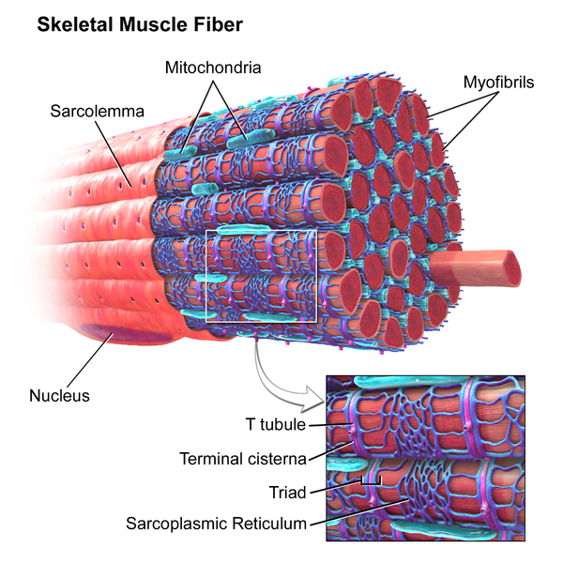

Skeletal muscle cells are long tubular cells with striations, which are specific characteristics that 3D bioprinter designers need to consider.

Image sources:
Skin anatomy diagram:
2013 Anatomy Box, Creative Commons Attribution Share License http://www.anatomybox.com/chapters/skin/
Bone anatomy diagram:
2016 Carl Fredrick, OpenStax Anatomy and Physiology, Wikimedia Commons CC BY-SA 4.0 https://commons.wikimedia.org/wiki/File:603_Anatomy_of_a_Long_Bone.jpg
Skeletal muscle fiber diagram (left):
Blausen.com staff (2014). “Medical gallery of Blausen Medical 2014.” WikiJournal of Medicine 1 (2). DOI:10.15347/wjm/2014.010. ISSN 2002-4436. https://commons.wikimedia.org/wiki/File:Blausen_0801_SkeletalMuscle.png
2014 Bruce Blaus, WikiJournal of Medicine Gallery of Blausen Medical CC BY-NC-ND-4.0 http://teachmeanatomy.info/the-basics/ultrastructure/histology-muscle/
Skeletal muscle cells micrograph at 1600x magnification (right-top):
2012 Regents of the University of Michigan Medical School via OpenStax College, Wikimedia Commons CC BY-SA-3.0 https://commons.wikimedia.org/wiki/File:414_Skeletal_Smooth_Cardiac.jpg
Skeletal muscle cells diagram(right-bottom):
2013 Mdunning13, Wikimedia Commons CC BY-SA-3.0 https://commons.wikimedia.org/wiki/File:Muscle_Tissue_(1).svg

