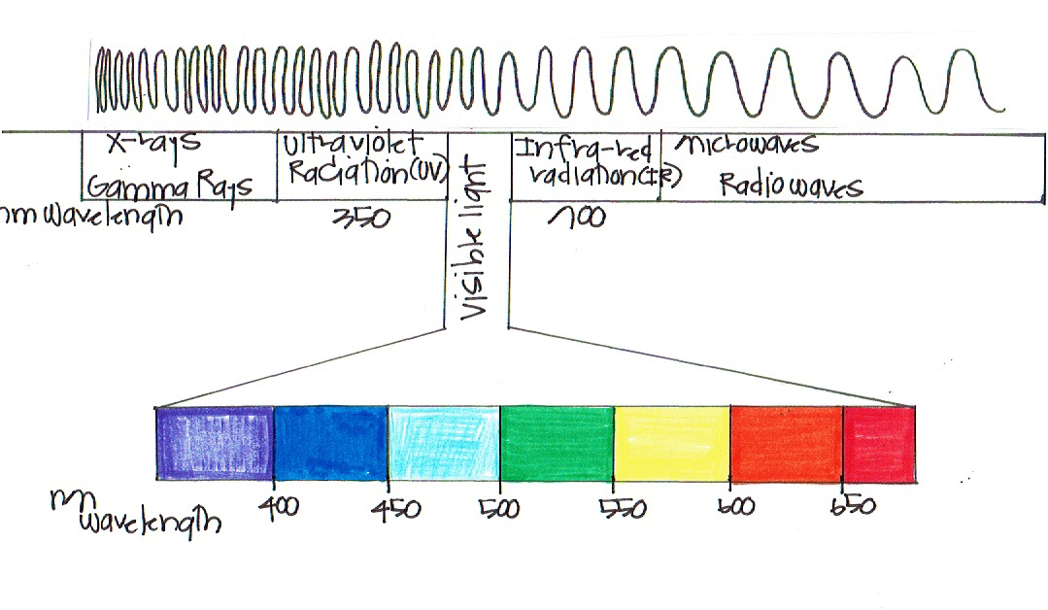
Blank Electromagnetic Spectrum Handout Answer Key

