**Flying with Style Activity – Rocket Launch Worksheet**

**C:\Users\yowell\AppData\Local\Microsoft\Windows\Temporary Internet Files\Content.IE5\MDI1T4QZ\MC900366266[1].wmfDirections**

You should have already completed building your rocket, following the instructions included with your rocket kit. Once finished with the construction of your rocket, see your teacher to install the wadding to protect your rocket parachute from engine burn.

**Altimeter Procedure**

Place a team member 100 m from the launch pad to use the altimeter. The measuring student should do the following:

1. Aim the device at the predicted height.
2. Press and hold the trigger of the rocket tracking gun while aiming at the rocket. This releases the angle finder.
3. Listen for teammates to count down.
4. Continue to hold the trigger; keep the crosshairs on the rocket as it travels.
5. As the rocket travels through the air, continue to hold the trigger until it reaches its maximum height.
6. Once the rocket has reached its peak (just before it appears to slow down or curve to return to the ground), release the trigger.
7. Take angle reading from the rocket tracking gun.

**Calculations**

Calculate the actual height of your rocket launch.

1. Predicted launch height ___________ m *(take this value from your calculated height from the* Rocket Calculation Worksheet *completed in the associated lesson)*

h

θ

x = 100 m

Actual launch height ___________ m (Note: Use trigonometry to calculate: h = x tanθ)

**Analysis**

Possible reasons the actual height was different than the predicted height?

**Rocketry Firing Instructions**

Preload your rocket as soon as it is available, at least 20 yards from the firing range in the designated loading area.

**Rule #1: Wear safety glasses at all times!**

**Rule #2: Follow all teacher directions for safety concerns!**

1. *If your rocket* doesnot *have a parachute, skip this step.* Using the wadding that is included with the each rocket, pack two or three of the sheets into the nose cone loosely and push down gently into the tube.
2. *If your rocket* does *have a parachute, follow this step.* Untangle, fold, and carefully insert the parachute as instructed. Each rocket comes with unique construction instructions, but most are similar to the steps described in the activity worksheet. This is described in steps 2 through 5 in the picture on page 3 of this worksheet.
3. Carefully, replace the nose cone.
4. Place the engine into the bottom of the rocket with the hole outward.
5. Next, place the engine cap to hold the rocket in place.
6. Place the igniter through the hole and into the rocket engine. *Be careful, as fragile leads may separate and not work properly. Take care not to cross the two leads, as they will short.*
7. Place the (pink) plastic seat to hold the igniter firmly in the engine, again, being careful not to let the leads cross.
8. Make sure the leads are separated and do not cross and to not pull apart too hard, as the leads may separate (the igniters are fragile).
9. Attach the alligator clips coming from the launch module to the two leads of the rocket and back up the full length of the wire.
10. Get the launch key from your teacher.
11. Put your team member who will take the altitude measurement at the 100 m mark, away from the rocket, ready to go.
12. Insert the launch key into the firing/launch mechanism (as described in the launch instructions that come with each launcher).
13. Count down 3, 2, 1, and fire when each measuring team member is ready. Fire by holding the key fully depressed, and press the launch button at the same time.
14. 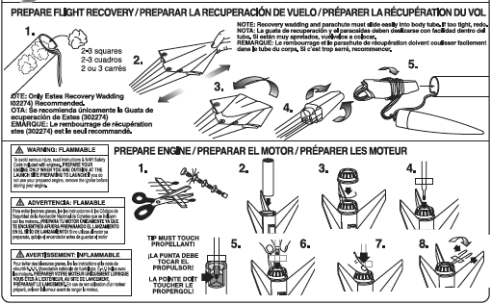Douse spent engines with water.