Testing Procedures Sheet

Tensile Test:

Materials:
- Pipe cleaners
- Table to support the hockey stick
- Set of weights
- Yard or meter stick

Set Up Procedure:
- Create a chart in the lab book with one column labeled Weight and one column labeled Deformation, similar to the one on the next page.
- Make rows in the weight column that have increasing weight of 0.5 kg increments.
- Wrap one pipe cleaner around one of the ends of the stick, 4 cm from the end.
- Tighten up the pipe cleaner but make sure you do not crush the stick.
- Place the stick on the table and tape 10 cm of one of the ends to the table with duct tape.
Testing Procedure:
- One group member should hold the meter stick from the ground to the end of the stick, near the pipe cleaner. Note the centimeter mark that is at the bottom of the stick.
- Add one weight to the stick using the pipe cleaner. If there is no change (if the bottom of the stick is at the same place before adding weights), put 0 in the right column. If there is a change, document the change by finding the difference between the starting centimeter mark and where the bottom of the stick is now.
- Continue to add weight and document changes until the stick breaks.

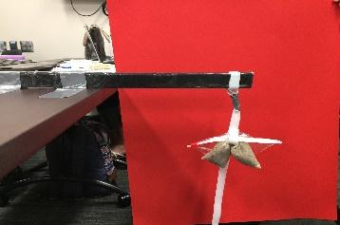

Weight | Deformation
1
2
3
4
5
6
7
8
9
10

