Activity Part 1 Worksheet: Force Sensitive Resistors Answer Key

Equipment Needed Per Group:
- One force-sensitive resistor (FSR)
- One solderless breadboard
- Two jumper wires
- One multi-meter capable of monitoring resistance

Objective:
Determine the relationship between physical pressure and resistance. Is it linear? Is it proportional? Inversely proportional?

Instructions:

- Insert the two pins of the FSR into two different rails of a breadboard. Note: Since an FSR behaves like a variable resistor, , there is no polarity in the connection.
- Set your multimeter to Resistance. Use AUTO if that’s an option because the resistance is highly variable and you may need to change the scale for different pressures.
- Attach jumper wires between the breadboard and the multimeter leads. If you have alligator clip leads, you can skip over the breadboard and attach directly to the FSR. In that case, you will need one person to hold the leads while another presses on the FSR.
Measuring resistance with a multimeter and alligator clips
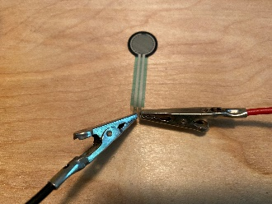 | 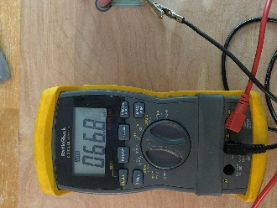 | 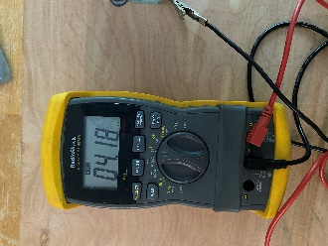 | 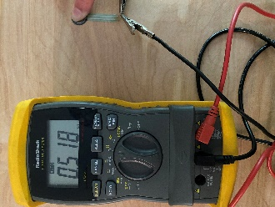
Clipping to FSR | Light Touch | Medium Touch | Hard Press

- If the built-in FSR leads are too short to lay the sensor flat as shown in the picture, use a jumper wire to hold the sensor in place on the breadboard. Make sure to not jumper together the two FSR connectors.
- Fill in the table using your measured values, not the values shown in the photos..
Pressure versus resistance data. Answers will vary but should DECREASE going down the column
Physical Pressure Applied to FSR | Resistance Measured (include units)
Light Touch | 66.8 kΩ (answers will vary)
Medium Touch | 4.18 kΩ (answers will vary)
Hard Press | 0.518 kΩ (answers will vary)

- Answer the questions:
  - Were you expecting the resistance to increase or decrease as you increased pressure on the FSR?
Answers will vary. Some students will answer INCREASE while others will respond with DECREASE as the answer.
  - What was the observed relationship between physical pressure and resistance across the FSR?
ALL students should respond that the resistance decreases with increased physical pressure.
  - Is there a way to determine from the above information if the relationship between physical pressure and resistance across an FSR in a linear function? Why or why not?
There is no way to determine linearity from the above information because there is no way to quantify the measurement of light touch, medium touch, or hard touch.

