What Is Heat? Quiz
Complete the statements below:
1. Flowing thermal energy is called _______________.

2. Heat transfer that occurs within or between solid objects is called ___________ ______ .

3. Heat transfer into and out of fluids (like air or water) is called
__________ ______ .

4. Heat always flows from ______________________ materials to ______________________ materials.

5. Ice water in cold air: Which way will heat flow?
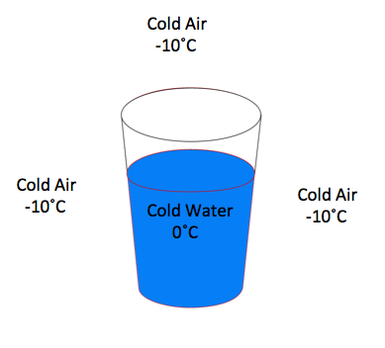
Draw an arrow between the air and the ice water below, showing the direction of heat transfer.

Multiple choice: (circle the correct letter)
- You accidently touch a hot iron and burn your hand.
What type of heat transfer caused this to happen?
  - electricity
  - convection
  - conduction
  - locomotion
- You are holding a glass of ice-cold water (32 °F) in a room that is 72 °F. Your body is 98 °F. What is the direction of heat transfer?
  - From you to the glass and from you to the room
  - From you to the glass and from the room to you
  - From the glass to you and from the room to the glass
  - None of the above
- It is a cool windy day and you start to feel cold.
What is the main type of heat transfer that is making you feel cold?
  - conduction
  - convection
  - solar
  - induction
- A material that slows down heat transfer is known as a/an:
  - conductor
  - thermometer
  - insulator
  - metal
- When you heat up a material (such as water),
  - Its molecules move more quickly
  - Its molecules slow down
  - Its temperature will drop
  - All of the above

