Post-Activity Quiz Answers

- What role does the fruit or vegetable play in the battery?

Answer: The fruits and vegetable are the electrolyte in the battery cell.

- What roles did the metals, e.g. copper penny, aluminum and/or galvanized zinc scree or nail play in the battery?

Answer: The copper penny is the cathode, the zinc screw/nail and aluminum are anode materials, where the copper releases electrons and the anode materials accept the electrons.

- Describe which battery configuration produced the highest power and describe why it produced more power than the other designs.

Answer: Batteries arranged in series produced more power than batteries arranged in parallel. When arranged in series, the total voltage is the sum of the voltage of each individual battery; batteries arranged in parallel produce the same voltage as one single battery.

- What is the relationship between the output current and the distance between the anode and cathode?

Answer: As the distance between the anode and the cathode increases, the output current increases.

- Give the definitions of an anode and cathode. Which metals in your experiments were anodes or cathodes?

Answer: The anode attracts electrons and is the positively charged electrode. The cathode is the negatively charged electrode that is the source of the electrons or an electron donor.

- Draw a diagram to illustrate the circuit design that produced the maximum amount of power.

Answer: Expect students to draw batteries in series, an example circuit diagram is shown below.

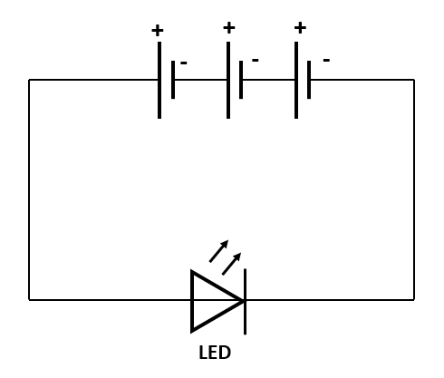

- Draw a diagram of the circuit that produced the correct amount of voltage and current to turn on the LED light bulb.

Answer: Student drawings will vary. They should produce a drawing of their individual successful circuits; circuit elements may be labeled with general terms (i.e., battery) or terms specific to their circuit (i.e., lemon).

- What are independent and dependent variables?

Answer: An independent variable is a variable that stands alone and isn't changed by the other variables you are trying to measure. A dependent variable is something that depends on other factors. For example, a test score could be a dependent variable because it could change depending on several factors such as how much you studied, how much sleep you got the night before you took the test, or even how hungry you were when you took it.

- In the following scenarios, identify the independent and dependent variables…

- cost of pizza and number of pizza toppings.
- How fast the grass grows and how much rain we get.
- The number of problems missed on a test and your grade on the test.
- How long I talk on my cell phone and the number of minutes on my calling plan.
- The amount of money I make and the number of hours I work.
- The number of cakes sold in a bake sale and the amount of money made.

10. You are given the following data on the relationship between John’s test score and the number of hours he studies.

Number of Hours John Studies | John’s Test Score
0 | 75
0.5 | 80
1.0 | 85
1.5 | 90
2.0 | 95
2.5 | 100

- What are the independent and dependent variables?

independent variable - number of hours John studied
dependent variable - John’s test score

b. How are the independent and dependent variables related? (Be as precise as you can)
As the number of hours John studies increases by 0.5, John’s test score
increases by 5 points.

