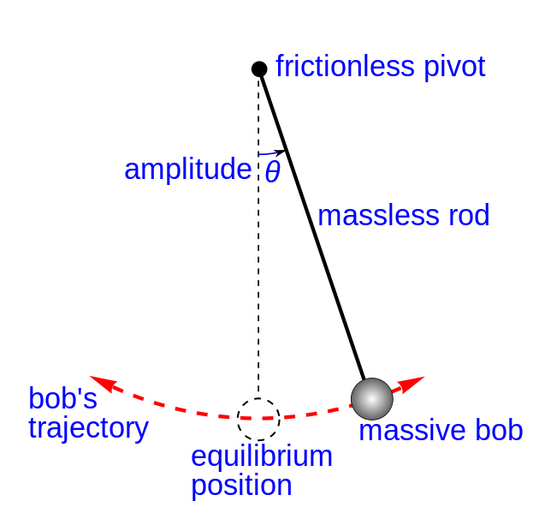

**An ideal model of a simple gravity pendulum.**

A “massive bob” suspended by a “massless rod” from a “frictionless pivot,” without air friction. When given an initial impulse, it oscillates at constant amplitude (Ɵ, theta), forever. The “equilibrium position,” hanging perfectly vertically, is indicated in dashed lines.

**Source:** 2008 Chetvorno, Wikimedia Commons <http://commons.wikimedia.org/wiki/File:Simple_gravity_pendulum.svg>

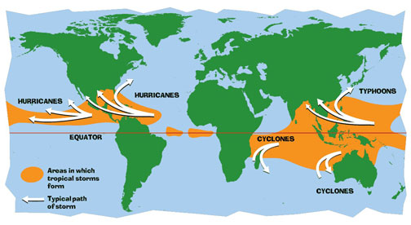

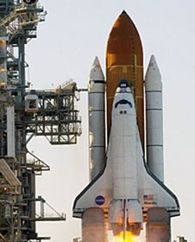



**x**

**Cape Canaveral, Florida**

**Source (map):** NASA http://pmm.nasa.gov/education/articles/how-do-hurricanes-form

**Source (shuttle photo):** NASA http://www.nasa.gov/audience/forstudents/k-4/stories/what-is-the-space-shuttle-k4.html#.Up0YjcRDuuN