Bacteria are Everywhere! Activity –
Where’s My Bacteria? Worksheet

Directions
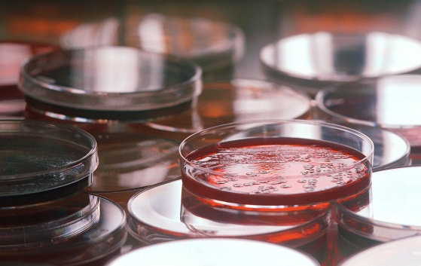
How effective is washing your hands or using hand sanitizer on removing bacteria? Let’s find out.
Samples of bacteria will be collected from the surface of your hands and the bacterial will be grown over time. To reduce experimental error, the samples should be taken from one student’s hand only, but under three different conditions:
- Unwashed hand
- Hand washed with soap and water
- Hand sanitized with antibacterial hand gel
Use this worksheet to collect and organize your data. Be sure to keep it since this experiment will continue for one week.
Part I: Streaking your Plates
- Choose one student in each group for each of the following roles: Sample Student (from which to obtain the samples), Swabber (the person who actually takes the samples), the Supervisor (the person who makes sure the correct Petri dish is being used) and the Washer, the student who oversees the washing and sanitizing of the sample students second hand. (Note: it is important to have all samples come from the same person to reduce experimental error.)
- Your teacher will hand out three pre-labeled Petri dishes to your group; please notice how each lid is labeled.
- Begin with the “unwashed” Petri dish. From the Sample Student, a second group member, the Swabber, should gently rub a cotton swab on the surface of that student’s palm. Do not lay the cotton swab down.
- The Supervisor, a third group member, should open the “unwashed” Petri dish containing agar.
- The Swabber should gently rub the cotton swab sample taken from the unwashed hand back and forth on the agar. Be careful not to apply too much pressure when doing this, otherwise the agar will tear.
- The Supervisor should close the Petri dish.
- The fourth group member, the Washer, should carefully wash one hand of the Sample Student’s hands with soap and water.
- The Swabber and Supervisor should repeat Steps 4-6 for this hand; being careful to streak the dish labeled “washed.”
- Finally, the Washer should apply hand sanitizer to the Sample Student’s other hand (the hand that was not washed in the previous step). Allow the hand to air dry until all gel has evaporated.
- Repeat Steps 4-6 for this hand, except being careful to streak the plate labeled “sanitized” this time.
Part II: Data Acquisition
Fill in the table below after analyzing the images of your Petri dish with the area covered by the bacteria (in centimeters squared). Record any comments or observations of the sample.
Sample | Area covered by bacteria (cm²) |  |  | Comments & observations
 | Day 0 | Day 4 | Day 7
Unwashed hand
Washed hand
Sanitized hand
Plot the area covered by bacteria of the three samples versus time (in days) in the graph below. Make one line for each sample, and chose a different color for each line. Make a legend to label which color corresponds with which sample.

Part III: Reflection
Answer the following questions to summarize your experimentation results.
- Which sample showed the most growth of bacteria? Was this the result that you expected?

- Did any bacteria grow on the sanitized hand? If so, do you agree with the common slogan that many antibacterial hand gel brands state, “Kills 99.9 % of bacteria!”?

- What do you think would happen if you were to steak plates with bacterial samples from other common surfaces, such as a doorknob, kitchen counter, railing near the subway/train? Comment on what you might expect based on your results.

