Bacteria are Everywhere! Activity –
Post-Assessment Bacteria Survey – Answers

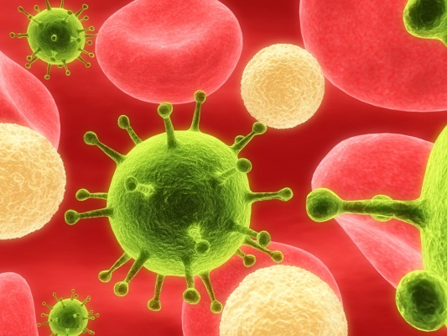
Directions
Please answer the following questions to the best of your ability, using your knowledge of bacteria and their growth.

- Name three factors that bacteria need for their growth.
  - water
  - nutrients
  - air/oxygen
- Do bacteria reproduce sexually or asexually? Circle one.

- How long does it take for a bacterial population to double in size?

- 1 minute
- 20 minutes
- 4 hours
- 1 day

- What temperature is the best for bacterial growth?

  - 15 ⁰C (59 ⁰F)
  - 25 ⁰C (77 ⁰F)
  - 37 ⁰C (98.6 ⁰F)
  - 45 ⁰C (113 ⁰F)

The following three questions are true or false questions. Circle your answer choice.
- Bacteria only grow in darkness. T F
- Bacteria are eukaryotes. T F
- Bacteria are unicellular organisms. T F
- Name one reason why scientists would want to grow bacteria in the lab.
Scientists are interested in growing bacteria in the lab:
1.) To study cell growth and communication, and
2.) To use the bacteria’s cellular machinery to grow valuable molecules like proteins.

- Name two methods that scientists use to count bacteria or monitor their growth.
- Optically monitor cell growth by shining light through cells being grown in liquid medium to see how much light is scattered. More scattered light indicates more cells in the solution.
2.) Using photographic techniques, one can determine how much of a solid surface (i.e., Petri dish) is covered by bacteria and quantify the growth.
- Did you enjoy the bacterial growth experiment? Why or why not?
Answers will vary.
- Is there anything you would have liked to do differently in the bacterial growth experiment?
Answers will vary.
- What did you learn about bacteria?
Answers will vary; no right or wrong answer.

