Linear Approximation Exit Ticket

I have several students who work in restaurants. The data in the table below shows how many hours they worked last week and how much money each one made, including tips.
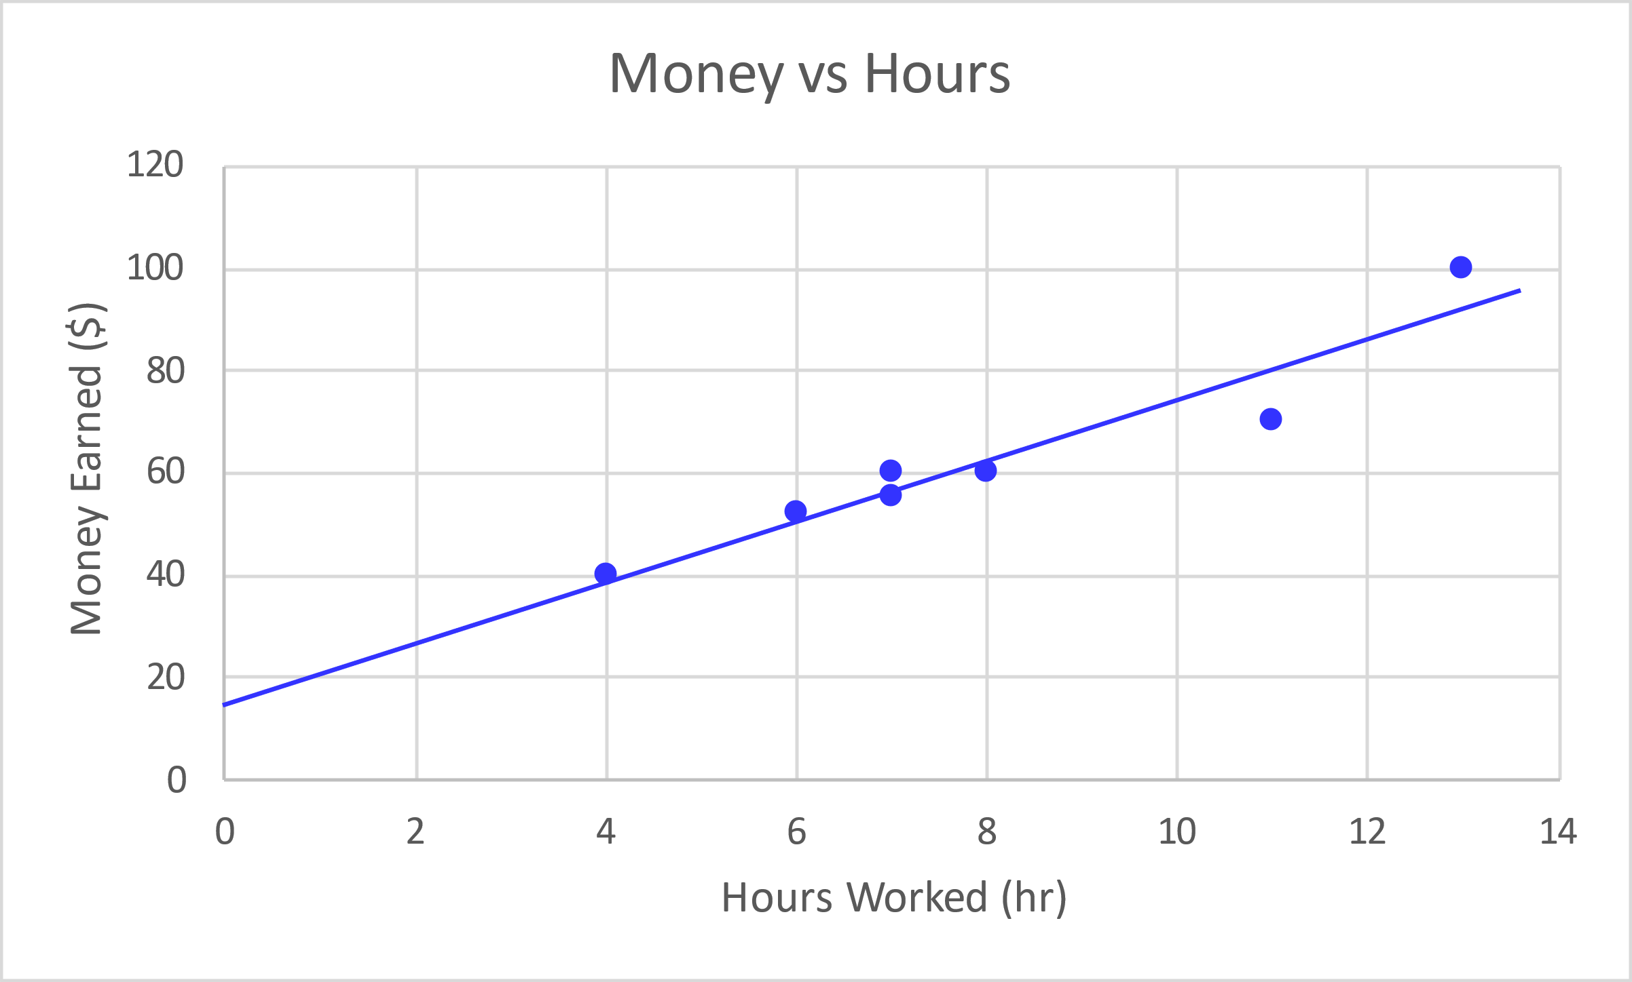
Hours | Money
7 | 55
4 | 40
11 | 70
8 | 60
6 | 52
13 | 100
7 | 60

Find the equation of a line that you think best follows the data. Show your work or include a justification of the values for your equation.

Use your equation to determine how much you would expect someone who worked 15 hours to make. Show work.

