**Simple Machines Scavenger Hunt! Answers**

Look around and fins as many simple machines as you can. Look closely; they are everywhere! Use the pictures below as a guide.

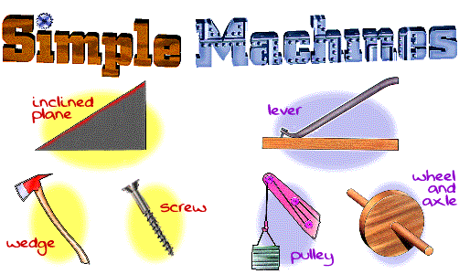

When you find a simple machine, write it down in the correct category in the table below. If you find a compound machine (one that combines more than one simple machine), record it in the compound machine row.

|  |  |
| --- | --- |
| **Simple Machine Type** | **Examples** |
| Inclined plane | **Hallway ramp, sidewalk ramp, desktop, slide** |
| Pulley | **Curtain, window blind, flagpole** |
| Wedge | **Doorstop, nail, zipper, scissors** |
| Lever | **Scale, stapler, hammer, see saw, bottle opener** |
| Screw | **Screw, bolt, jar lid, clamp, car jack** |
| Wheel and axle | **Carts with wheels, trash can on wheels, door knob, rolling chair, scooter, bicycle** |
| Compound machine | **Dolly or hand truck (lever and wheel and axle). Paper cutter (lever and wedge)** |

