Make a Battery Worksheet Answers

- Draw a picture of the potato battery setup in the space below. Label the potato, wire, and light bulb parts. Draw arrows to show the direction of the current.
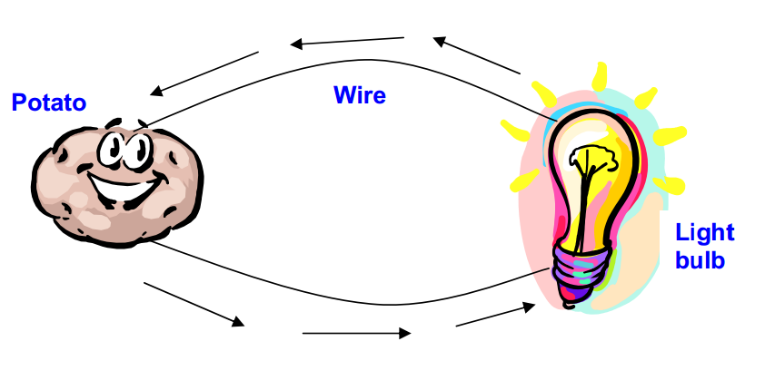

- How does the potato help the circuit to work?
Potatoes give the electrons a solution to help them move to the copper to the zinc, and complete the circuit.
____________________________________________________________________________

____________________________________________________________________________

____________________________________________________________________________

- Why must engineers understand circuits when making electrical appliances?
Engineers need to understand circuits in order to force electrical energy flow through the right resistors in technologies that run off electricity.
____________________________________________________________________________

____________________________________________________________________________

____________________________________________________________________________

