Close Encounters of the Polymer Kind Lesson –
Close Encounters Lesson Handout for Students
Purpose
In the modern age with technology all around us, sometimes we fail to realize how one particular type of material has completely shaped our lives. The seat that you rest on, the panels that make up your car, the shampoo that you wash your hair with, even the oil the helps your engine run contains this special material.
Polymers
But what are polymers? They are often overlooked and seldom taught in any depth so it is understandable that we may have to dig deeper when it comes to polymers. A better understanding of polymers helps us engineer better products for the future.
The goal of this lesson is to introduce polymer materials, to discuss how polymers behave different than “simpler” materials, and then to show some of the unique behavior polymers can possess. The concept to be thinking about is—Why does a polymer behave differently than water?
Weissenberg Effect
The Weissenberg Effect is the instance where a polymer travels up a rod, in contrast to say water that moves away from the rod as it spins. By considering the differences between long chain polymers and water, we can figure out why this is the case.
As you already know polymers are long chain atoms, most typically with carbon-carbon backbone. These chains interact and entangle, similar to a pile of string. For the case of water, the water has a certain affinity to the rod. As the rod spins, the centrifugal effect throws the water molecule away from the rod. For polymers, however, there are many more interactions with the rod per molecule and so much more force is required to remove the polymer from the rod. The chains are also entangled, so as the rod tries to throw the chain off the rod, it has nowhere to go and begins to wrap around the rod. As the chain wraps around the rod, it drags more chains closer to the rod due to entanglements. This explains why polymers come close to the rod.So this explains why polymers come close to the rod, but why do they travel UP the rod.
Entropy
Say the classroom was a fraction of the size and you were forced to be extremely close to one another. What would you want to do? Move in closer or move away from each other? Obviously, you would want your own space and move away from each other. You would want plenty of room to stretch your arms and legs. Polymers (anything for that matter) are the same in that they too want to increase entropy, or disorder of the system.
Enthlapic Interactions
If you are standing next to your friend, it is not so unpleasant that you are unable to do so, even in close proximity. There is an attraction between both of you. However, if you are next to your enemy, you would be inclined to move. There is repulsion between both of you. This is analogous to enthalpic interactions. Polymer chains also experience attraction and repulsion due to Van der Waals forces. Given that all the chains are very similar, the chains like each other.
The desire for you to move is balanced between the desire to increase entropy and the enthalpic interaction with your friends. In the case of the polymer chain, their desire to increase their ability to stretch about is greater than their attractions, and some net movement has to take place. Since they can’t move down the rod without running into other polymer chains, the only option is to move up.
Assessment
- What did you observe in the Weissenberg Demo?

- Why do the chains actually travel up the rod?

- In your own words describe entropy and enthalpy?

- In your own words, describe what enthalpic and entropic interactions are?

- Does nature want to maximize or minimize entropy?

Barus (Die Swell) Effect
The Barus Effect is similar to the Weissenberg Effect in that it can be explained by the balances of the entropic and enthalpic contributions. Think back to the YouTube video of the three effects. What happened in the Barus Effect? As the polymer exited the die (mold), it expanded and swelled. The figure below shows a general scheme of this effect. Let’s see if we can work out why.
If we consider the classroom analogy again, we can get a good idea of what is happening. You are in a classroom, but one of the walls moves in and out. As the wall slowly moves toward you, you eventually have to move closer and closer to your classmates until you get become close enough that through either (or both) entropic or enthalpic contributions, you want more space and you begin to push back on the wall. Now imagine the door suddenly opens and you are allowed to leave. You are naturally going to pour out into the hallways and spread out. This is essentially what happens with the Barus effect.
You have a bunch of polymer chains in a confined space and the plunge slowly puts energy into the system forcing the polymer through the die. As it does this the chains have to move in closer together (decreasing entropy) and the chains align. The chains move through the die, while pushing on the walls. Once the chains exit the die, they are free to relax and stretch out again by swelling (increasing entropy).
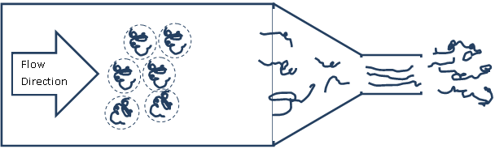
In the large diameter section, the polymer chains are relaxed and take up a more natural configuration.
As the diameter restricts, the polymer chains get closer together and deviate from that equilibrium configuration. Once the polymers exit the die, it can return to a more favorable shape by expanding.
Assessment
- Which has more entropy available: a chain that is forced to be straight or a chain that can freely move?

- Explain why water does not swell after exiting the die?

- Compare the state of entropy in the die and the one after the die. Is it different or roughly the same?

Kaye Effect
The Kaye effect is a little different. There are a few different theories as to why this takes place so what we explore here may be only part of the reason (or possibly not the reason).Write down your observations of the Kaye effect, as seen in the lesson video.

Shear Thinning and Shear Thickening
The polymer appears to “skip” off the surface— possibly due to what is known as shear thinning. The polymer outside of the polymer stream shear thins and acts as a lubricant, allowing the stream to slide or skip off the surface.
Shear thickening is the exact opposite of what is happening in the Kaye Effect video. With shear thickening, a material gets stiffer as you run/move across it. In fact, the faster you move, the easier it is to cross the material. With shear thinning, the material gets softer as you run across it. The faster you run, the softer the material gets.
To understand this concept, let’s consider the YouTube video in which students run across a pool of cornstarch and water, commonly called ‘oobleck’ (https://www.youtube.com/watch?v=yHlAcASsf6U). This demonstrates shear thickening—the exact opposite of what is happening in the Kaye Effect video. In the cornstarch example, the material gets stiffer as you run across it. In fact, the faster you run, the easier it is to cross the material. With shear thinning, the material gets softer as you run across it. The faster you run, the softer the material gets. Think of the floor; although it is solid, you would fall through it if you ran across it too fast if it was shear thinning.
Let us try to explain this on a molecular level. See the figure below as a reference.
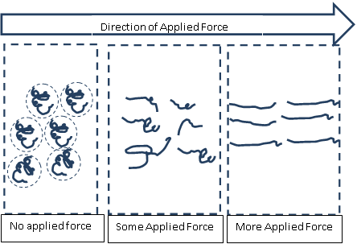
When no force is applied, the polymers are in a relaxed state. As more and more force is applied (it is also depends on how quickly it is applied but we can save that for another day) the polymers stretch out and can slide past one another.
Imagine that you are a long polymer chain. You have had sufficient time to relax and reach a state that minimizes your free energy (maximized entropy). This shape that you would be in would roughly resemble a sphere (think about why water droplets form). As you move about, you collide with other spheres roughly the same size as you, and it takes considerable time for you to go around each other. As stress (energy) is applied to the system, you are disturbed from your little sphere and are forced to stretch out as you collide with each other. You are not allowed time to relax back to the original state (time constraints), and you remain in this stretched state. You and your neighbors become aligned. You are no longer colliding with large spheres. Instead you are just sliding past each other. Your resistance to flow or viscosity is greatly decreased and you can appear to skip off the surface.
Assessment
- Explain shear thinning?

- Explain shear thickening?

Thermosets
Previously we discussed some of the molecular dynamics of thermoplastic systems including how the ability to relax affects a material's properties (think of shear thinning or shear thickening). Let's switch our focus to thermosets. Say we take the thermoplastic system we saw earlier through the Weissenberg Effect demo, but now we anchor the molecule in place every few points within the molecule. Now the molecules cannot move as well. Anchor a few more points, and the material gets stiffer as the molecules lose the ability to move around. A macroscopic (large scale) example of an anchored thermoset would be a bridge, as shown in the figure below. In the first illustration, the bridge has very few connections.
Do you think this bridge would be very stiff or somewhat flexible? (It is somewhat flexible). Now we take the exact same material, but make a few more connections. What happens to the stiffness? (It goes up).
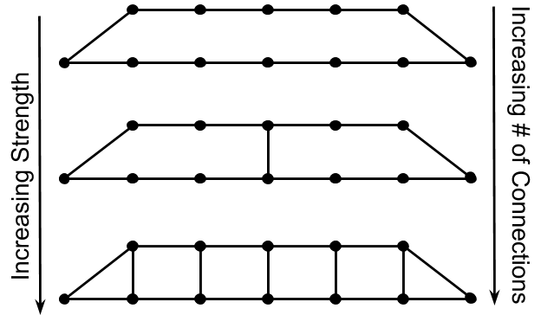
Bridges with a differing number of connections.

Now let’s discuss how we can change the number of crosslinks at a molecular level. Figure 4 illustrates two difunctional molecules—that is, two sites within the molecule that are reactive towards each other. If they react, they can only create a linear chain of connections.
Is the polymer now linear if we have a thousand difunctional molecules (500 A and 500 B) and exchange a single “A” with a single trifunctional molecule (D)?
And, what happens if we exchange it for two trifunctional molecules?
What if we directly exchange 10 B molecules for 10 D molecules?
What if we completely replace the 500 B molecules with 333 D molecules?
Every A functional group can react with one D functional group—perfect number of connections due to a stoichiometric ratio.
What if we keep going and add 1,000 trifunctional molecules? Are there enough difunctional molecules to react with all of the trifunctional? (Answer: There are not, and now you have loose ends again which causes the material to become flexible again.) This happens through a reaction between an epoxy (difunctional molecule) and an amine bearing molecule that possesses more than two functional groups (shown below).
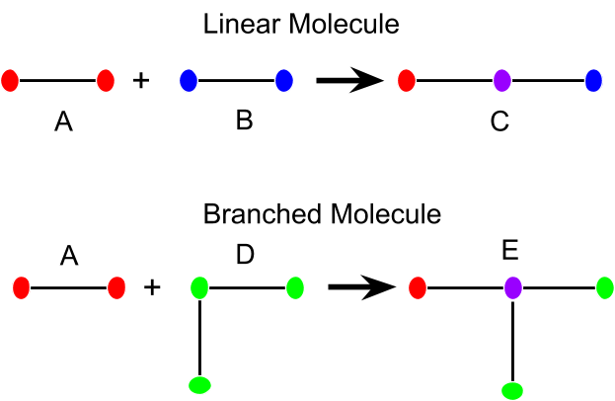
Real Life Example
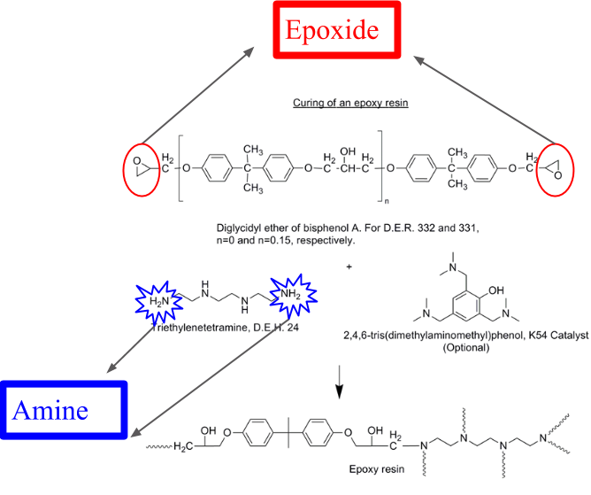
Above is an illustration of an epoxy resin. It involves reacting an epoxide group (circled in red) with an amine group (circled in blue) to create the crosslinked structure showed at the bottom of the figure. Tthe squiggly lines denote cross links with other similar molecules. Common examples of this are car bumpers or panels and wind turbine blades. By varying the ratio of epoxide and amine you can manipulate the mechanical properties exactly as we discussed earlier.
Summary Assessment
Answer the questions below in complete sentences.
- In your own words, what is a thermoplastic and a thermoset? List one of each.

- Can you change the shape of a thermoset material?

- If you want a flexible thermoset do you need a few or many connections?

- If you want a stiff thermoset do you need a few or many connections?

- Are the crosslinks in thermosets physical entanglements or covalent bonds?

- When you have no loose ends, you have a ______________ ratio of functional groups.

