Design in Different Views
You will draw your final design’s top, side, and front views. This will help you think about what your design will look like, and will also help you when you begin building your design.
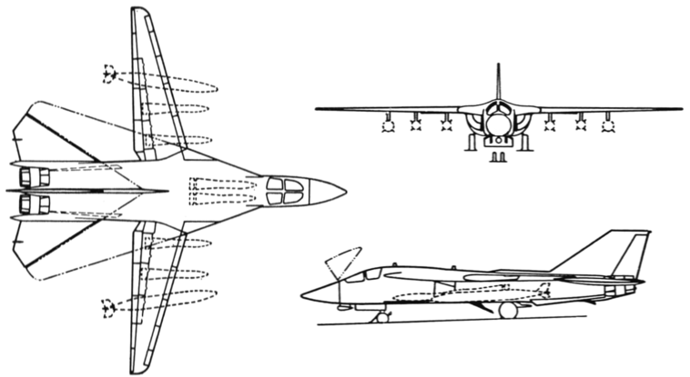
For example, this picture shows the top, front, and side views of the airplane. This way, you know what the airplane looks like from every angle.
Top View:

Side View:

Front View:

