Accessible Toys Lab Sheet

Station 1: Maze Activity

Goal: Complete the maze while under different constraints.

Materials: Laminated maze, blindfold, visually impaired goggles, dry erase marker

Instructions: Make sure to erase the maze after each attempt.
- Complete the maze while blindfolded.
- Complete it while wearing the visually impaired goggles.
- Complete the maze fully sighted.

Complete the following questions:
After completing the mazes, discuss the difficulty of completing the maze on your lab handout.
As a group, discuss how the others in the classroom affected your ability to complete the maze.

Observations
First try (Blindfolded):

Second try (Visually Impaired):

Third try (Fully Sighted):

Station 2: Sensory Activity

Goal: Use your sense of touch to count out 50 cent worth of coins, while blindfolded.

Materials: container of assorted coins, blindfold

Instructions:
- While fully blindfolded, reach into the bowl of coins and try to count out enough coins to equal 50 cents.
- Repeat this three times.
- Record your actual count on your lab handout.

Complete the following questions:
- How do you know the difference between coins?

- Is there a weight difference?

- Where you surprised about what you counted?

Observations
Count 1
Count 2
Count 3

Station 3: Introduction to Braille Activity

Goal: Become acquainted with the Braille alphabet.

Materials: puffy paint
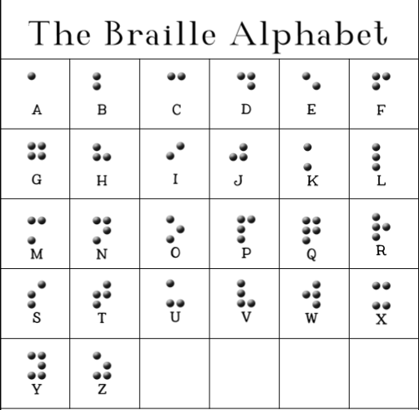

Instructions: Using the Braille alphabet, create your first name below with puffy paint.

Station 4: Vision Empower

Goal: Research Vision Empower, a non-profit organization in India.

Materials: Laptop/tablet/Chromebook

Instructions: Research Vision Empower on the internet and write your notes in the space provided below:
Questions to complete on your handout:
- From researching Vision Empower, what does this organization do and how do they support visually impaired students?

- Where is this company located?

- What events has Vision Empower hosted that you found interesting? Why?

