Linear Regression Pre-Quiz
Instructions: Answer all questions. You will use all these skills during the activity.
- Define “line of best fit”:

- Draw a line of best fit for the following scatter plots:
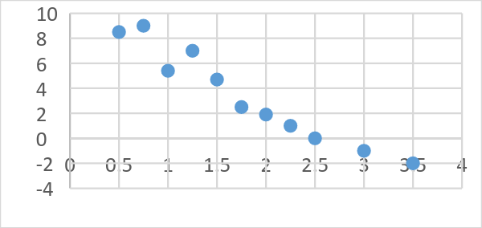
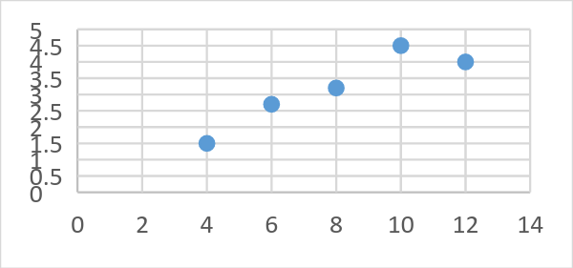

- Find the equation of the line through the following points:
  - (-1, -10) and (3, 2)

  - (2, 5) and (-4, 2)

- A ball is rolled down a hallway and its position is recorded at five different times. Use the data in the table below to predict the location of the ball at 12 seconds. Answer:
Time (seconds) | Position (meters)
1 | 9
2 | 12
4 | 17
6 | 21
8 | 26

- Calculate the average speed of the ball in question 4. Show your work.

- A car accelerates from a standstill to 60 m/s in 10 seconds. What is the acceleration?

- A car accelerates from 25 km/hr to 55 km/hr in 30 seconds. What is its acceleration?

