Android Acceleration Assessment ANSWER KEY

1) What is acceleration?
Acceleration is the rate of change of velocity.
2) How can velocity be calculated using an acceleration vs. time graph?
Since acceleration is the rate of change of velocity, the integral of the acceleration curve gives the velocity. To find the velocity of the Android device, you can estimate the area under the curve or find an equation for the acceleration curve and perform integration.
3) How can the maximum velocity be found using an acceleration vs. time graph?
Relative maximums in velocity will occur at times when the acceleration switches from positive to negative.
The velocity at these times can be found by integrating the acceleration function (or finding the area between the graph of acceleration and the time axis).
Students will write answers and justifications for the following:
1) A particle has an initial velocity of 0 and moves in a straight line and acceleration modeled by the a(t) = 200 sin(π t/50) for 0 ≤ t ≤ 100.
a) Draw a sketch of a(t) and in a well-written paragraph, describe the linear motion of the object on the interval 0 ≤ t ≤ 100.
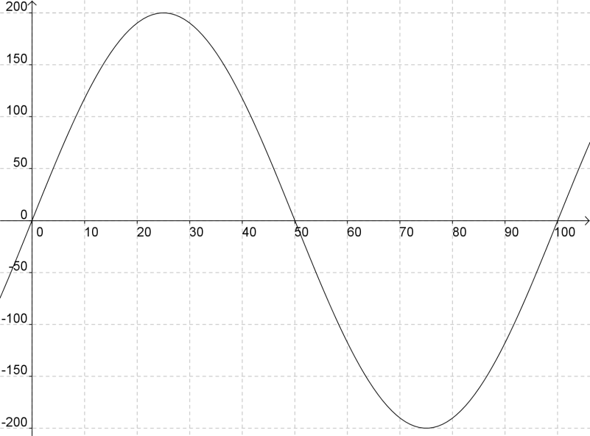

Between t = 0 to t = 50, the particle as a positive acceleration, meaning the particle is gaining velocity. Sine the initial velocity is zero, the velocity and acceleration between 0 and 50 are both positive, so the particle is speeding up in the positive direction. At t = 50, the acceleration switches to negative, implying that the particle is slowing down but till heading in the positive direction until t = 50 when the accumulated velocity nets to zero, implying the particle comes to rest.

b) For what value of t does the particle attain its maximum velocity? Justify your answer.
The particle attains its maximum velocity at t = 50 since a(t), which equals the v’(t), or the derivative of velocity, switches from positive to negative at this value.
c) At approximately what velocity is the particle moving at the time found in part b? Show the computations that lead to your answer.

The exact answer is $\int_{0}^{50}{a(t)}dt=\frac{20000}{π}≈6366.2$. Any method of
integration a(t) from 0 to 50 will produce solutions based on a desired
accuracy. Examples include using an antiderivative, calculator, Riemann sum approximations, or simple geometric approximations from the area between the graph of a(t) and the x-axis.

2) In a complete sentence, describe the relationships that exist between the position, velocity, and acceleration functions for a particle moving in a straight line

If a particle moves in a straight line, and its position is modeled by a function x(t), then the velocity of the particle can be modeled by the derivative of x(t), x’(t), and the acceleration of the particle can be modeled by the second derivative of x(t), x’’(t).

