Don’t Bump into Me! Post-Quiz Answer Key
- List three real-world examples of tools, technologies or equipment that use the echolocation concept.
Radar systems: airplane navigation, weather and storm monitoring, polar ice formation/melting measurement
Sonar systems: ship navigation, fishing, underwater sea floor mapping for depth, navigation dangers and marine ecosystems
Ultrasound medical diagnostic equipment: pregnancy, internal organs, tumors
Measuring distance and speed: radar guns, radar, sonar

- Provide an example “stimulus-sensor-coordinator-effector-response” framework for one of your real-world examples.
Example: Radar on an airplane transmits sound waves into a region in the flight path > sound sensor in the radar system receives reflected sound waves > computer calculates the presence and location of rain, snow, clouds, storms and other planes > computer sends instructions by wires to display screen showing colored map of location of weather and obstacles > pilot adjusts flight path and/or elevation for safest route
Example: Ultrasound medical device transmits sound waves into belly > ultrasound device receives bounced-back sound waves (sound sensor) > computer makes sense of the sound waves > sends instructions to monitor to form a picture of fetus inside belly > mom learns of baby’s health and if it is a boy or girl
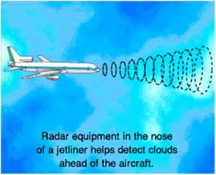
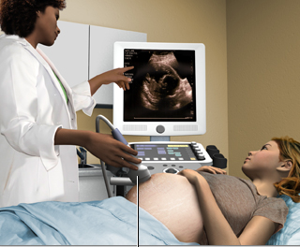

Images sources: NASA http://virtualskies.arc.nasa.gov/communication/8.html and MedlinePlus, U.S. National Library of Medicine, National Institutes of Health http://www.nlm.nih.gov/medlineplus/ency/imagepages/1110.htm

