Waits, Loops and Switches Worksheet Answer Key

- Program the robot to perform the following (first, attach to your robot 2 touch sensors, name them A and B):
  - Stay at rest and display “Ready” on the screen.
  - Move left and display “Left” whenever touch sensor A is pressed.
  - Move right and display “Right” whenever touch sensor B is pressed.
  - Move forward and display “Forward” whenever both touch sensors A and B are pressed.
  - Stay at rest and display “Stop” when no buttons are pressed.

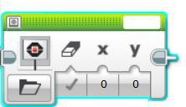
➔ Hint: Click on the from the drop-down
icon, drag the block into the program, and select “Text” menu to display text on screen.

- Brainstorm about possible programming solutions and write below the one that your group thinks is the best one. Write in English the various steps that are necessary.

- Display “Ready” on the screen

- If touch sensor in port 4 is pressed
  - Display “Forward” and move forward

- Else if touch sensor in port 1 is pressed
  - Display “Reverse” and go backwards

- Else if touch sensor in port 1 and 4 is not pressed
  - Display “Stop” and don’t move

- Repeat Steps 2-4 forever

- Draw the various EV3 blocks that will be needed in the program.

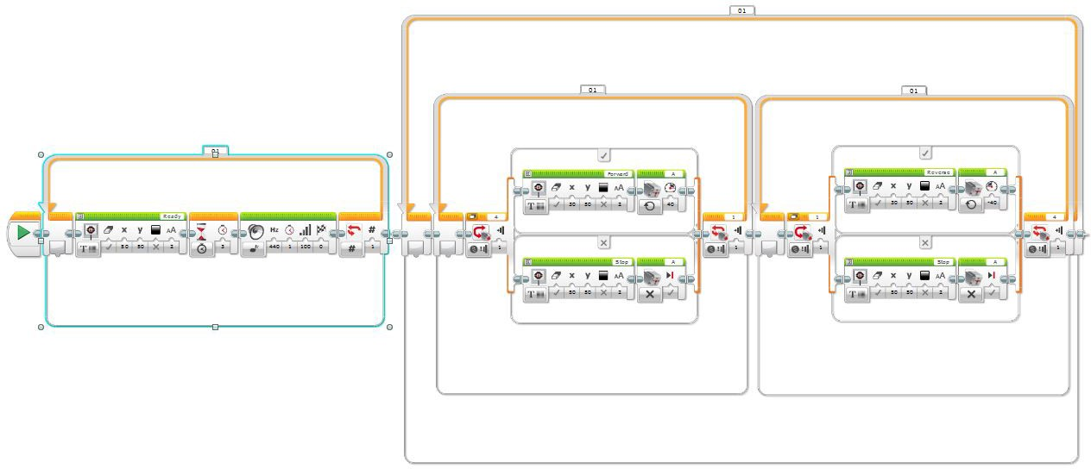

➔ Then use the LEGO EV3 software to create your program, download and test it with the robot and sensors, revise and retest as necessary until it works as a successful solution.

- Did you have to “iterate” (make changes to the program, etc.) to make it work? How many iterations did you have to perform? Explain.
Answers will vary. Example answer: No, we did not have to iterate; our program worked the first time through.

