Engineering Design Process Notebook

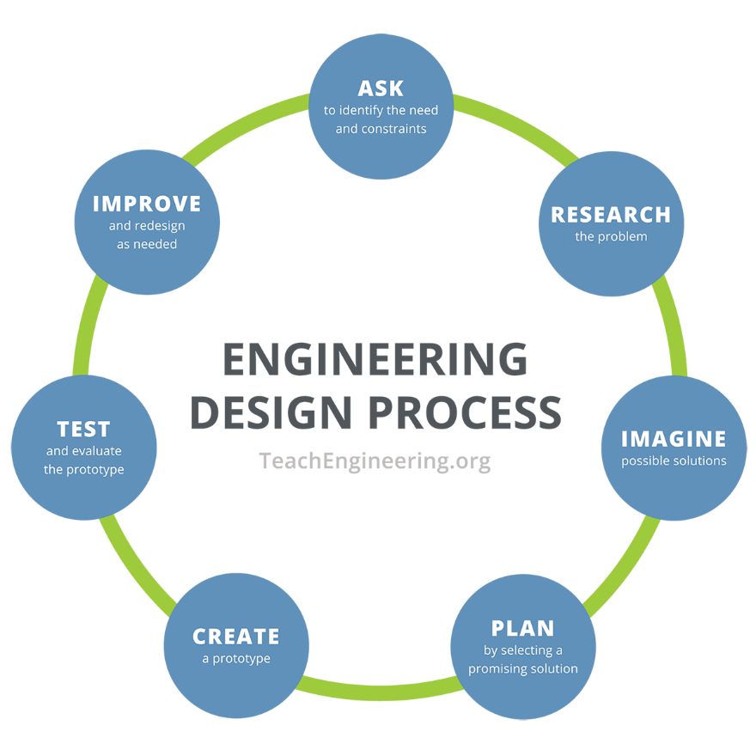

- Identify the needs and constraints. List the needs and constraints of the shin guard.
- Research the problem. What designs already exist? What works and what needs improvement?
- Brainstorm/create possible solutions. List ALL ideas in the group and include sketches. Attach additional paper if necessary.
- Plan a solution. Describe the chosen solution and list as many details as possible including who will be responsible for providing what materials. You must account for all materials and list the price of any purchased items as well as the total spent.

- Create: Keep track of what is working, what is not working, and any design changes that needed to be made.
- Evaluate the prototype. Honestly evaluate your prototype in comparison to the other group designs.
- Improve the design as needed. Discuss as a group what you would change if you had the time to redesign.

