Practicing Measuring Capacitance / Testing Your Sensor Sheet
Directions: The diagrams below show different objects being tested on a capacitance sensor. Use the digital multimeter readings to complete the calculations and then answer the questions.
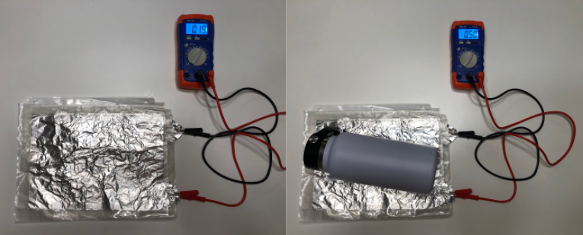
0.50 nF
0.15 nF
The Water Bottle
Initial Capacitance (nF) | _________ nF
Final Capacitance (nF) | _________ nF
Capacitance of Object (nF)  (Final Capacitance –  Initial Capacitance) | _______ nF - _______ nF =  ________ nF

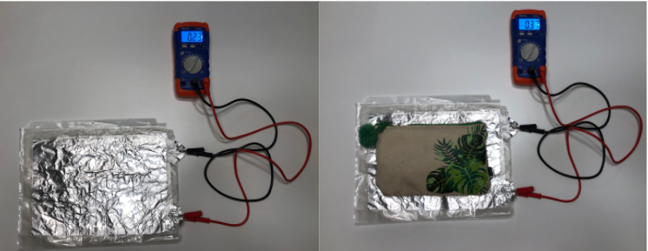
0.37 nF
0.23 nF
The Pencil Case
Initial Capacitance (nF) | _________ nF
Final Capacitance (nF) | _________ nF
Capacitance of Object (nF)  (Final Capacitance –  Initial Capacitance) | _______ nF - _______ nF =  ________ nF

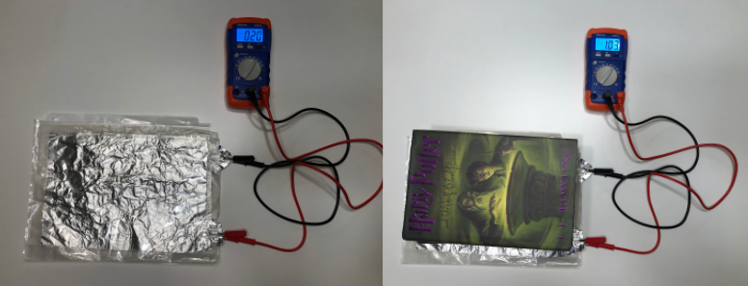
1.03 nF
0.20 nF
The Stack of Books
Initial Capacitance (nF) | _________ nF
Final Capacitance (nF) | _________ nF
Capacitance of Object (nF)  (Final Capacitance –  Initial Capacitance) | _______ nF - _______ nF =  ________ nF

According to your calculations on the last page, answer the following questions:

- Which object had the least capacitance? _______________________________

- Which object had the highest capacitance? _______________________________

Your sensor does NOT measure pressure, but capacitance and pressure are related. As capacitance increases, pressure also increases. Based on this information…
- Which object do you think exerts the least pressure? _______________________________

- Which object do you think exerts the most pressure? _______________________________

- Explain how you decided to assign the least and most pressure to the objects in #3 and #4:

__________________________________________________________________________________

__________________________________________________________________________________

__________________________________________________________________________________

__________________________________________________________________________________

Testing YOUR Sensor Directions: Choose one to three objects from your classroom to test on your capacitance sensor and record your data below:
Object | Initial Capacitance (nF) | Final Capacitance (nF) | Capacitance of Object (nF)  Final Capacitance – Initial Capacitance

Object tested with the most capacitance: ___________________________

Object tested with the least capacitance: ___________________________

