Tower Masters Research Worksheet (GrK-2) Answer Key
- Define by cutting and pasting from the picture choices below:
An engineer is a person who uses:
 | + |  |  | to create
 |  |  |  | to solve a problem in the world.
A civil engineer is a person who designs all kinds of structures, including public works such as:
 | 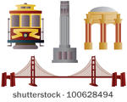 | 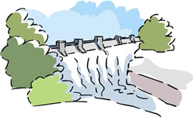

---------------------------------------------------------------------------------------------------------------------------------------------------------------------------------

Choose from the following items to cut and paste answers to questions 1 and 2.
Research the problem |  | Imagine: Develop possible solutions |  | Improve: Redesign as needed
 | Ignore the problem  X |  | Create: Build a prototype
Plan: Select a promising solution |  | Create a hypothesis  X | Ask: Identify the need and constraints | Test and evaluate prototype

- The engineering design process is a series of steps that guides engineers as they design and redesign structures and other inventions without wasting a lot of money, time and materials.

Ask: Identify the need and constraints
Imagine: Develop possible solutions
Create: Build a prototype
Improve: Redesign as needed
Test and evaluate prototype
Plan: Select a promising solution
Research the problem
Engineering Design Process

