Spaghetti Soapbox Derby Pre/Post-Quiz Answer Key
- Which of the following actions will increase the gravitational potential energy of an object?
Circle all that apply.
- Change the object’s color by painting.
- Increase the height of the object above the ground. (1 pt)
- Add more mass to the object. (1 pt)
- Push the object so it travels faster along the ground.
- In the diagram below, label the position of the pasta car that correspond to the following:
- The highest kinetic energy (1 pt)
- The highest potential energy (1 pt)
A
B
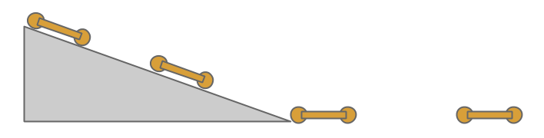

- You are tasked to design a new car for the XYZ motor company. Your manager tells you that the vehicle must weigh less than 2,000 lbs. and be shorter than 13 feet in length. The engine and the seats inside have already been designed by other engineers. Given these instructions, what is one design constraint that you must follow?
The car must weigh less than 2,000 lbs, OR The car must be shorter than 13 feet long. (2 pts)

- Will any two objects traveling at the same speed have the same kinetic energy? Why or why not?
No, not necessarily. If both objects are traveling at the same speed, they also need to have the same mass in order to have the same kinetic energy. (2 pts)

- Would changing only the rolling resistance of a vehicle change the amount of potential energy it has at the top of the ramp?
No, the potential energy is not impacted at all by the rolling resistance. (2 pts)

