Projectile Motion Problem Worksheet
SHOW YOUR WORK. Acceleration due to gravity: a = 9.81 m/s²
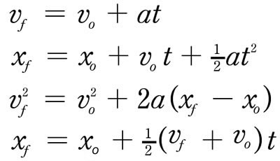
1.
2.
3.
4.

- A ball is dropped from 4 meters above the ground. If it begins at rest, how long does it take to hit the ground?

- A ball is thrown upward at 4 meters per second starting from ground level. How long does it take for the ball to return to the ground?

- If a ball that is 4 meters above the ground is thrown horizontally at 4 meters per second, how long will it take for the ball to hit the ground?

- In question 3, how far will the ball travel in the horizontal direction before it hits the ground?

- Drop a ball from a height of 2 meters and, using a stopwatch, record the time it takes to reach the ground. Repeat this two more times and record all the times in the table below, then find the average time. Be sure to release the ball from rest rather than throwing it up or down.
Test Number | Time (seconds)
1
2
3
Average

Now, use a kinematic equation to find the final velocity of the ball (just before it hits the ground). Use this final velocity to show that energy is conserved from Time 1 (just before the ball is released) to Time 2 (just before the ball hits the ground). Use the equations below for potential energy and kinetic energy (h = height of the ball; m = mass of the ball).
$$PE=mgh KE=\frac{1}{2}mv^{2}$$

