Boom Construction Activity –
Boom Construction Contract Form
The rules listed below cannot be changed; any questions or disputes must be resolved prior to construction.
Competition Rules
- Each team will have the opportunity to use as much of the materials as they want, but some materials do have a cost. Other materials are free, but may add unnecessary weight.
- Each bridge/boom should span (go across) an 11-inch space. Tip: This distance can be increased but doing so may make the bridges fail sooner.
- Each bridge will be loaded at increments of 5g-20g, until it fails.
- Each bridge is considered to fail once it has “sagged” or deflected by the ratio shown below. A ratio is used in civil engineering to measure acceptable deflections in the real world. This ratio is modified to allow greater sag to allow more competitiveness among teams.
L/22 =.5in 11in/22 =.5in (in real-life the ratio is L/360)
This means once your bridge has sagged by .5-in., it is considered to fail at the weight that it is currently holding. About 5 sec should be given at the initial point of sagging to consider a bridge as failed, due to wave and spring motion (bridge bouncing up and down from the weight being loaded into the cup).
NOTE: If an EV3 sensor is used to measure this distance, it should be done in centimeters with a value of 2. The sensor already has this value built into the program.
- ONLY the following materials, sold at the stated costs, can be used to construct bridges:

- Construction Paper @ $0.145/sheet (This should be reduced to the same cost as copy paper, if construction paper is not stiffer than printing paper)
- Printer Paper (11x8) @ $0.065/sheet
- Index Cards @ $0.035/card
- Tape: Free
- Glue stick: Free
- Scissors: Free

- The team that wins the competition is the team with the highest Final Ratio (FR). The FR consists of the following four ratios:
- Weight Ratio (WR) – ratio between final weight and self-weight of the boom
- Cost Ratio (CR) – ratio of final cost and a constant
- Cost Estimation Ratio (CER) – determines the accuracy of cost estimation
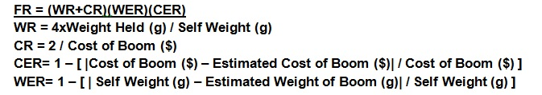
- Weight Estimation Ratio (WER) – determines the accuracy of self-weight estimation
NOTE: Both CER and WER should be 0<CER&WER<1, thus reducing CR by the error percentage. Both CER and WER are accuracy equations that use absolute value.
- The estimated cost and estimated weight has to be provided to the teacher by each team prior to the start of Part II and cannot change. Teams may only alter these values during Phase I, Planning.
- The boom cannot be taped to the table (or supporting structures).

Our company understands that ordering any materials during construction will affect our boom’s CER value. Our company order:
________ (# of sheets) copy paper ________ (# of sheets) construction paper ________ (# of) index cards

Our boom weight estimate is: ___________ grams
Our boom cost estimate is: $ ___________

