Proteins Have Different Functions in Our Bodies
Reference Sheet
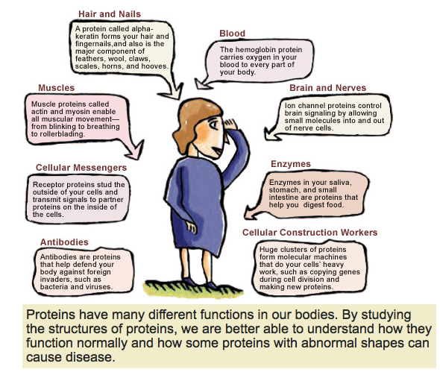

Source: 2011 National Institute of General Medical Sciences https://publications.nigms.nih.gov/structlife/chapter1.html

