Post-Assessment Worksheet Answer Key
Instructions:
- Draw your critical zone cross section in the box below.

My critical zone cross section
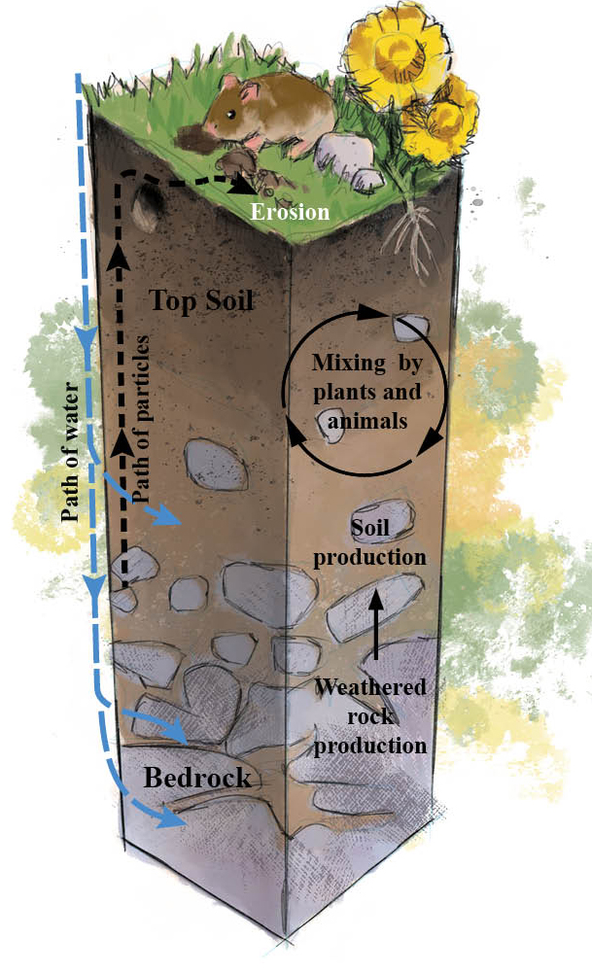
Bedrock
Saprolite
Subsoil
Topsoil
Organic

- Label the following layers in your cross section:
  - Bedrock
  - Organic layer
  - Subsoil
  - Saprolite
  - Topsoil

