j0215372[1]**Acid Rain Worksheet**

Draw a picture of your chalk “sculpture.”

**Predict**

What do you think will happen when you put your chalk into the liquid?

**Data**

What liquid did you put your chalk in? __________________________

While you are waiting, use your litmus paper to measure the pH of all three liquids:

The pH of **lemon juice** was _____________.

The pH of **tap water** was ______________.

The pH **of vinegar** was ________________.

Draw a bar graph of the pH of each liquid.

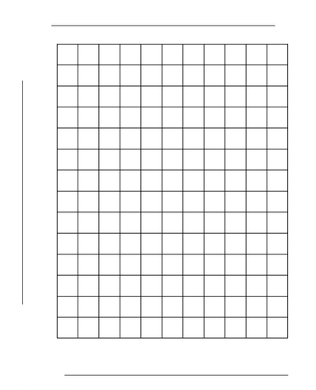

**Results**

Draw a picture of your chalk after it set in liquid.

**Conclusions**

Compare your chalk with the chalk of the other members of your group. Which chalk looked the worse?

Which liquid — **lemon juice**, **tap water** or **vinegar —** is the most acidic (dissolved the chalk the most and lowest pH value)?