The Power of Food Activity –
Pre-Activity Reading

How Does a Battery Work?
A battery can supply voltage to a device because it has a cathode, or positive terminal, and an anode, or negative terminal. A simplified explanation of how a commercial battery is constructed is that a positive terminal, often a carbon rod, and a negative terminal, actually the zinc case surrounding the battery, intrude upon each other using a liquid acid to create an electrical current. (Imagine a small tin can with a rod placed vertically in the center with a small protrusion on one end, which is the positive end). Specifically, the carbon rod is placed in the acid, called a conductive solution. This liquid allows ions to move within the battery and between the positive and negative terminals. While the full, technical explanation is a bit more involved, this provides a picture of how the battery is constructed.
What is the acidic solution that produces this movement of ions, you ask? Well, aside from just calling it battery acid, which is very hazardous, it is an electrolyte solution that is made up of various chemicals—the battery type determines which chemical(s) are included in the solution. The chemical reaction in these types of batteries has a finite end. These types of batteries that are charged from a chemical electrolyte solution are considered disposable or one-time use batteries; they cannot be recharged, which is a huge concern for the environment.
Food as a Battery Source
There are many everyday foods and liquids that can act as effective conductors. For example most fruits, some vegetables, and fluids that contain electrolytes—which includes most acids and bases—are conductive.
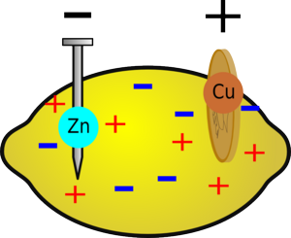
To create the same positive (cathode) and negative (anode) terminals, as those found in a commercial battery, a copper penny and galvanized zinc nail or a paper clip can be used to make a battery at home. The two metals are pushed into fruit, vegetables or an electrolyte solution to create the positive and negative terminals. The two terminals are then connected to create an electrical circuit via a wire that is capable of conducting electricity.
Activity Description
In this experiment, we compare different household items for the amount of electricity they can produce. The goal is to produce the most electricity and to illuminate the most LED bulbs compared to other groups. The electricity produced by food can be measured using a multimeter, which your group will measure and record.

