Hands-On Activity Template

Part 1: Activity Overview
Activity Title | Click or tap here to enter your Activity Title.
Focus Grade Target | Click to select a grade.
Time Required: | Click or tap here to enter the Time Required. Estimate the time required to complete the activity in minutes; you may add a brief explanation for longer activities, such as “three 50-minute class periods”.
Group Size  Check the box that applies to this activity. | Independent (1 student) ☐  Pairs (two students) ☐  Small groups (three to five students) ☐  Whole class) ☐

Instructional Summary – 200 words

Summarize what your activity is all about in one paragraph using the present tense. See an example.

Click or tap here to write your Instructional Summary.

Classroom Testing Information
Briefly describe the K-12 classroom or informal learning center testing conducted with this curriculum. Please include the date, school, location, grade level, and number of students.
Click or tap here to enter Classroom Testing Information.

Educational Standards
In priority order, list up to four educational STEM standards that students would learn because of completing this activity. If students need a prerequisite skill to complete the activity, then list what is required.

For each standard, include the source, year, grade band, standard nomenclature (e.g., number(s)/letter(s)), and standard summary. Example: North Carolina, science, 2004, 1.01 (grades 8-8): Identify and create questions and hypotheses that can be answered through scientific investigations. ID# S1028531

Provide at least ONE from each of the following:
Click or tap here to enter text.
List Next Generation Science Standards (NGSS)
Click or tap here to enter text.
List Common Core Math Standards (optional)
Click or tap here to enter text.

Learning Objectives
Using bullet points and statement form, identify up to three main goals or student outcomes of the activity. For example:

After this activity, students should be able to:
- Describe the flow of electrical energy through a simple circuit.
- Discuss the effects of gravity and friction in the context of their roller coaster designs.
- Solve problems involving pressure, density and Pascal's law.
- Think and outline design iteration suggestions.
See an example.

Prerequisite Student Knowledge
List any skills or knowledge a student must already have in order to be successful in this activity, such as knowledge of a certain concept or topic, specific math skills, etc. Example: “A familiarity with compass directions” or “A basic understanding of gravity and friction” or “The ability to calculate median, mean, and mode.”

Click or tap here to enter text.

Part 2 Activity Instructional Plan

Equipment and Materials
Provide a bullet list of equipment and materials and the quantities needed for each group/class needs for the activity; this includes multimedia resources such as links, YouTube/Vimeo videos, etc.

We recommend providing source information, part numbers, estimated pricing, and/or links to online stores to assist teachers in finding unique items, etc. Make sure all materials and equipment are listed in the Procedure below.

Provide all measurements in metric units. You may also provide customary US or English units as a secondary measurement. Example, “a length of string, 2 m (~6 ft.)” For example:

Each group needs:
- 1 laptop computer
- 1 scale
- 10 g iron filings
- 1 Arduino Uno microcontroller (available online) for $20
For the entire class to share:
- poster paper
- cardboard
- magic markers

Click or tap here to enter text and follow the examples above.
Introduction and Motivation – at least 250 words (or 1/2/ page)

Introduce the activity and create a hook to pull students into the activity.
Engage students in authentic and meaningful scenarios that reflect the practice of science and engineering as experienced in the real-world.
Provide support for teachers to cultivate student questions that come from their experience, community, or culture as appropriate. What investigating questions would you ask to motivate them?
Provide opportunities for students to connect their explanation of a phenomenon and/or design problem to questions from their own experience.

Include teacher instructions and answers in parentheses, such as: (Write the equation on the classroom board.) or ( (Possible answers: xxx, yyy, zzz.)]

Click or tap here to enter your Introduction and Motivation brief.

Procedure

Clearly explain the step-by-step procedure to follow to conduct the hands-on activity. Make sure to include connections to engineering and address activity objectives. To clarify the activity setup and procedure, reference images throughout this section and the activity write-up. Use figure numbers if the image is referenced in the text. Include metric units. Use the following format below. See an example.

Background (for teachers only; use as a guide to help students make sense of the concepts on their own)

Clearly explain any essential background information (such as the explanation of science, engineering and/or math concepts related to the activity) the teacher may need to know to successfully complete this activity. Usually in paragraph format.

Click or tap here to enter Background text.

Before the Activity (how does a teacher prepare for the activity? – example text and formatting below)

- Gather materials and make copies of the worksheet…
- Describe any other pre-activity preparation here…
- (Bullet format suggested)

Click or tap here to explain the Before the Activity procedure.

During the Activity (outline the exact steps a teacher follows to guide students in the activity – example text and formatting below)

Step 1 or Part 1

- Example: Divide the class into groups of three or four students each…
- Describe step-by-step procedures here…
- (Numbered list format suggested)

Click or tap here to explain how to perform the activity With the Students.
(For images, see Part 5: Photos and Images below on how to properly reference and cite images in your submission.)
Assessment (Pre-Activity, Formative, and Summative)
Provide assessment tools/activities for teachers to assess the learning objectives. How do you know if the students “got it” during and after the activity? Provide active and embedded ways (formative assessment*) for the teacher to gauge what students are learning about the topic/content throughout the activity, and a performance-based way to assess student understanding of the learning objectives at the end of the activity (summative assessment).
Browse the TE collection for example assessment tools and activities. See an example.

Pre-Activity Assessment

Click or tap here to enter text. Descriptive Title: Describe the assessment procedure so the teacher knows what to do. Include detailed sample items and/or list the name of the actual assessment that you will be attaching. .

Activity Embedded (Formative) Assessment

Click or tap here to enter text. Descriptive Title: Describe the assessment procedure so the teacher knows what to do.

Post-Activity (Summative) Assessment

Click or tap here to enter text. Descriptive Title: Describe the assessment procedure so the teacher knows what to do; if posing discussion questions, provide example answers. Include detailed sample items and/or list the name of the actual assessment that you will be attaching.

Making Sense Assessment

Have students reflect on the science concepts they explored and/or the science and engineering skills they used by completing the Making Sense Assessment.

Academic Vocabulary | Definitions (you may source definitions from Wikipedia or Wiktionary; )
orbit | The gravitationally curved trajectory of an object.
particle | A small localized object to which can be ascribed several physical or chemical properties such as volume, density, or mass.
See an example.
Click or tap here to insert a table and add text.

Troubleshooting Tips and Potential Safety Issues
Click or tap here to enter text. Think through likely common snags that might be encountered while conducting the activity. Suggest solutions, approaches to avoid pitfalls, etc. What should you consider if the activity does not work right the first time? What could you change?
Worksheets and Attachments
List the names of any documents you will use as part of this activity such as presentations, handouts, assessments, coding language, etc. Please also provide answer keys for all handouts/assessments. Upload these documents separately along with this template.
Clearly label each activity and include the activity name in the file (for example, all-about-bridges-homework-assignment.docx. TeachEngineering accepts most files in an editable format including Microsoft Word (.docx) Microsoft Excel (.xlsx) Microsoft PowerPoint (.pptx), JPEG files (.jpg) and Portable Network Graphics (.png) and others. If you have any questions, please contact your editors at TeachEngineering.
See an example.

- Click or tap here to enter text.
- Click or tap here to enter text.
- Click or tap here to enter text.
- Click or tap here to enter text.
- Click or tap here to enter text.

Part 3: Supporting Activity Information
Scaling, Extensions, and Enrichment
Click or tap here to enter text. Explain modifications or suggestions to activities that would make them more or less challenging for use at various grade levels, For example: reducing or increasing the number of redesign steps, shorter time period to complete the activity, graphing the collected data, etc. Example lead-ins:
- For lower grades,
- For younger students,
- For upper grades,
- For older students,
- For more advanced students.

References (optional)

List all references used to create the activity, especially the background knowledge section.

Consider using a modified MLA format. Provide in A-to-Z order according to authors’ last names or website banner page name, whichever appears first in citation.

Part 4: Contributor, Supporting Program, Acknowledgements
Contributors
Click or tap here to enter text. List the names of any person who participated in the development of this activity (teachers, mentor, lab director, education staff, etc.). List the primary author first.

Supporting Program and Acknowledgements
Click or tap here to enter text. If this instruction was developed as part of a special program, list the name of the supporting program and/or organization.

Example: Research Experience for Teachers (RET), Center for Bio-mediated & Bio-inspired Geotechnics (CBBG), in partnership with Arizona State University, Georgia Institute of Technology, New Mexico State University, University of California-Davis, and the National Science Foundation.
.

Part 5: Photos and Images
Activity Photos
TeachEngineering requires a minimum of two original photos per activity to help teachers visualize the nature of the activity. We don’t expect nor require expert photos—smartphone photos work fine! However, we would like to see how teachers and students engage in the activity. (There are placeholders below for photos, but we encourage you to add as many as you like.)

You may supplement images sourced from the internet as long as they are licensed for public use (see Requirements and Tips for Using Images). Note: if authors plan on submitting photos that include their students, the author is responsible for securing the permissions from parents, guardians, or administrators.

You may include illustrations or diagrams (known as a figure) that specifically reference a topic within the text. For example, in explaining the parts of a cell or how a suspension bridge works, a figure may reference that explanation. Figures may also be used to help explain how to build a tool or a machine.

Reference where you want the image to go in the activity by simply saying (Insert Image 1) or (Insert Figure 1) in the text above and attach the photo in a box below.

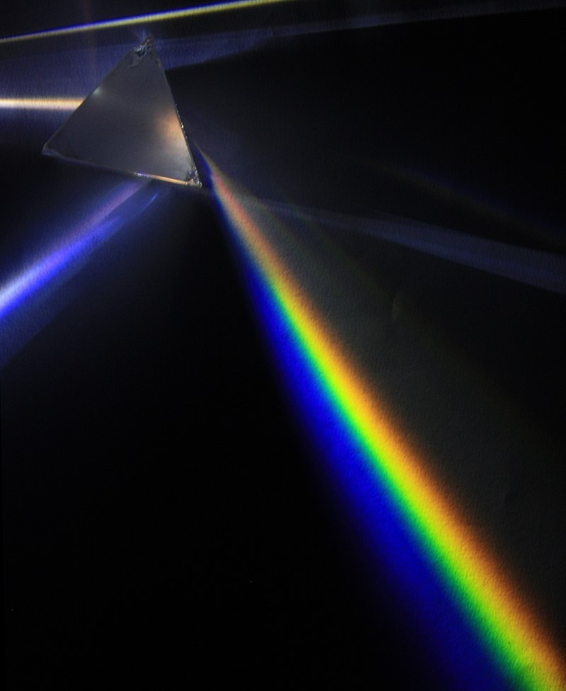
How to format images and figures; see below for a finished example:
Image 1: Insert into Procedure under “Day 1”
Image file: lesson01-image1-prism.jpg
ADA Description: A glass prism sits on a black background; a light source shining through the prism is demonstrating refraction of white light into the visible light spectrum.
Source/Rights: 2009 D-Kuru, CC BY-SA 3.0, Wikipedia, source link.
Caption: Why does white light diffract into the colors of a rainbow when it shines through a prism?

Click the center of the box below to upload an image.
Image 1 / Figure 1: Enter the location of where you want the image or figure in the text by saying (Insert Figure 1) here.
File name: The photo must be included as an attachment and must have the exact same name as you type here.
Example: lesson05-image1-pilot.jpg
ADA Description: Write this text as if describing key elements of the image to a blind person.
Source/Rights: Include copyright or identifying information for any images used. Images pulled from the Internet should be either in the public domain or licensed for use through Creative Commons (CC-BY or CC-SA); you must still attribute them to the person or website from which they were pulled as well as provide a direct link to the image.
Caption: This text will appear directly below the Image. This should not be the same text as used for the ADA Description.

Image 2 / Figure 2: Enter the location of where you want the image or figure in the text by saying (Insert Figure 1) here.

File name: Example: activity05-image1-pilot.jpg

ADA Description:

Source/Rights:

Caption:

